OCR GCE A

COMPUTER SCIENCE PROJECT

H446-03

Name: Omongoose

Candidate Number: <INSERT CANDIDATE NUMBER>

<Institution Name>: <INSERT CENTRE NUMBER>

Title of Project: Crocks-Syndicate

H446-03 – Project CONTENTS

Table of Contents

A. Analysis 3

B. Design 8

Systems diagram 9

C. Developing the coded solution (“The development story”) 9

D. Evaluation 9

Project Appendixes 10

# A. Analysis

## PrOBLEM Identification

The project I wish to complete is a 2.5D (Visually is 3D but in terms of mechanics is 2D) Top-Down puzzle solving game, where the player can explore a series of dungeons (caves) that will contain puzzles to access rooms, monsters that defends those rooms as well as an incentive to dive into these dungeons. The “loot” that can be earnt in these dungeons could be weapons, armour, valuables, etc. The loot would be generated based on the “level” of the dungeon, the type of puzzles/enemies inside, and the player. The dungeons would also be generated. However, they would be generated procedurally with pre-made art/tiles, meaning it will be rare that two consecutive dungeons share the same structure. Although, if I have extra time, I will try to implement procedurally generated art.

## Stakeholders

The stakeholders for my project would be any gamers that may enjoy a puzzle/fighting game that will keep them entertained, for the stakeholders my game has to be enjoyable, and repeatable (They will want to come back and play it again after playing it), attractive (looks good so they will want to play it in the first place).

The game has to, by the bare minimum, have a good game loop meaning the player can keep playing and the gameplay not cut off abruptly. The stakeholders will consist of casual gamers, since the game won’t be too intense or laid back it lands in the middle of competitive and relaxing games.

## Research

To better understand who my stakeholders are and what they would want in a game, I created a form that was distributed across some classes in my school and also across some others that I believe would have insight into what a game should have and what should have the main focus.

The form consisted of questions like:

* How long have you been playing games? (I prioritise the responses with the higher number of hours and lowest number of hours, this is so I can see what a newer player expects and what the experienced players need)
* What genres of games do you play and why? (So, I can see what features/ genres hold players interest)
* What platforms do you play on?
* Rate features in order of importance? (So, I can see what features I should focus on the most during development)
* What is your gender? (This was didn’t really hold much value for the project, I was just intrigued to see how much difference there is in how people are brought up and how exposed to games they are based on their gender, there was limited data on this though due to the majority of IT students being male[89%] )
* What other features would you like? (This was so I could gather more feature ideas that I didn’t already think of)

At the time of writing this I have 28 responses to these questions.

With this first question, I asked the age of the person doing the form. This is so I can compare the different answers of different age groups and see how they differ and what group likes what features.

For question 2 and 3, I asked the email and name of the person so I could potentially contact them in the future for more insight, I will not be showing photos of these questions for privacy purposes.

For question 4, I asked the persons gender, as you can see there seems to be an overwhelming majority of people who identify as male in the IT classes who completed the form.

For question 5, I asked how often the person plays games on a daily basis, (other was for if someone wanted to be more specific). Here it seems that the majority of people player between 1-3 hours, so more casual gaming. This data lines up with the stakeholders I am looking for, people who play casually, so I can keep the people who played 1-3 hours in mind for future testing.

Question 6, I asked what platform people play on, the majority of people answered PC. This means in the future when I am developing the code, I can focus on making it work best on PC, but still add support for controllers since a decent amount of people play on console.

Question 7, I asked how many years the individual has been playing games, this was so I could support experienced players and non-experienced players. By doing this, I can consider what a new player wants and experienced players need.

Skipped over question 8 since it’s not related to the topic.

For question 9, I asked what genres people played. From the group of individuals, they seem to have favoured Action more over anything. Since my idea is of a stealth/puzzle mix it seems it may be at a disadvantage within this group, so to make sure it is still favoured I will make sure that there is a healthy amount of action. Not enough to change the core idea of the game but enough that the game is appealing to a wider audience.

For Question 10, I asked a rather simple question, I didn’t really mind all too much about the answers, and since it was simple it led to mostly simple answers such as the most common answer being “fun”. However, the individuals that did answer with more detail have saved me some research since they have provided features and what genre they relate to. With this knowledge I can sway the genre of my game by introducing some of the features these individuals have pointed out to be enjoyable.

Skipping 11 since it is similar to 10 and didn’t get too much useable content.

For question 12, I asked the user to rate a selection of features in order of importance to the players experience. This allows me to prioritize during development in order to get what the player wants done sooner with more detail. It seems that the majority believe that the story in a game is most important to the user experience, however because I am making the game, I think I might only make an outline of the story and if I have time at the end, I will fluff out the story. I was a bit surprised to see character customization above lighting but it seems that choosing the characters appearance is important for some people.

Question 13 is similar to 10, it wasn’t too much of an important question, only there to potentially save some time researching in the future. A common theme with this question is the detail of the environment, despite my game idea being 2.5D (looks 3D but mechanics are 2D) I do want to add more detail but that will be second to getting it to work.

For Question 14, I did a similar thing to 12 and asked users to choose what they prefer and why (why is Question 15), most people seem to like Pre-made worlds for the reason that more detail can be put into them, in 2nd was procedural worlds where the environment around the player is never the same across saves and generates procedurally. Some people still liked user designed content, such as levels in super Mario maker, but it isn’t voted as good as the other 2. For my game I’m thinking of making procedurally generated levels. However, I may have some puzzles created by hand as a sort of tutorial, so its fairer for new players.

The last question (No.16) was just asking if anyone had anything else to add. This question only brought 1 valuable answer and that was to potentially add a secret ending, or an achievement like system. This will encourage players to keep playing the game and give them goals to achieve as sometimes, games without goals can get repetitive and lose interest.

Games like my project idea already exist, such as “Hogwarts Legacy” which contains trials for the player. These trials are similar to my idea in the fact that they are a sort of dungeon that contains enemies and puzzles which rewards the player, it is also similar to “Dungeon and Puzzles”(2021) in which the character goes through dungeons and has to complete puzzles to advance further, there is also the game “Binding Of Isaac” which is the most like my game idea.

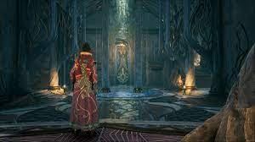**Overview:**

In Hogwarts Legacy ,the user can go through trials to progress in the game, there are 4 trials, one for each “Keeper” in the game. These trials consist of some small puzzles and fighting enemies. From my knowledge there is a boss at the end of every trial, these bosses usually have a lot of health and have attacks that forces the player to either dodge or perform some sort of mechanic to avoid damage. These boss battles are usually quite difficult and don’t offer too much reward but progress in the main quest line.

The player experience while going through these trials is usually to prepare beforehand by gathering health potions, so they can regain health while in battle, and slowly but smoothly progress through the trial, completing puzzles and killing enemies gaining various items throughout their journey, this experience continues up and until the boss battle at the end where it is much more difficult, if the player dies during the battle they respawn just before the battle so they can try again. The player will continually attempt to kill the boss before finally leaving the trial victorious.

**Relevance To My Project:**

In my project, I plan to avoid some of these mechanics but adopt others. I like the aspect of while progressing through the trial the player can complete side-puzzles to gain extra items or experience points towards a quest or skill, all the while killing enemies and unlocking more rooms. I, however, do not like the aspect of only being able to leave by either aborting the quest or completing it fully. I would like to have a system so that the player can leave the trial/dungeon at the end of any room, however leaving will have a drawback on final rewards and quests. I would also like to give the player the ability to abandon the boss fight and leave the dungeon if it is too hard.

Overall, Hogwarts Legacy is a good game and has some great features that I wish to include in my project, but it also contains some features that I would like to avoid since they increase difficulty for not too much reward.

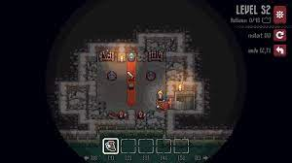**Overview:**

In Dungeons and Puzzles, on each level there is a puzzle that the user has to complete that allows access to the next level, the player can challenge themselves to make the least amount of moves by thinking logically about the puzzle. The user can use a sword to attack monsters, or a bow and an arrow to destroy enemies from afar. They can also push obstacles back with a shield and pull the monsters with a pair of gloves that can be picked up if on a level.

The dungeon has 150 hand-crafted levels to complete, that the player can go through and attempt to complete and optimise their approach. It also has nice top-down pixel art that give the illusion of a 3D environment with mechanics being 2D in nature. For my project I wish to replicate this type of art and have similar mechanics.

**Relevance To My Project:**

In my project, I wish to have a similar approach to this, where the player can progress through levels in a dungeon completing puzzles and killing enemies, but I want it so the player can move freely throughout the level and have it so movement doesn’t use a tile system, but the environment will use a tile-based system for generation and collision.

**Overview:**

The Binding Of Isaac is a roguelike game inspired by the biblical story of Isaac, it is a 2D top-down dungeon crawler game.

The player controls Isaac, or one of seven other unlockable characters, throughout a procedurally generated dungeon in his mother’s basement. The combat system is real-time meaning that the player and enemy don’t have to wait to attack and can do so at any point. The player can move throughout the dungeon collecting items, power-ups and fighting enemies. The goal is to defeat all of the monster bosses and eventually Isaac’s mother.

When playing the game if the player dies, then it is a permanent death, meaning they will lose that playthrough and won’t be able to play as that character (No respawning).

**Relevance To My Project:**

This game has a lot of features that I plan to have in my project such as levels that the player will progress through, and in “The Binding of Isaac” the rooms once cleared of enemies, will stay cleared and the player can go backwards through the dungeon. In my project I want to make it so that once a player completes a room and leaves it the puzzle will either reset or monsters reform, but will deactivate, meaning that the player can walk past and go backwards and won’t have to worry about refighting them again, but they will still be there, this could be used in the story later.

In my project, I also want to have multiple dungeons that the player can go through and complete or fail, that may change in some way once the player finishes them, such as reforming, a new room appearing, a room disappearing, a theme shifts inside of the dungeon, new enemies etc. This will make the player want to redo completed dungeons in the future.

## Essential Features

For my game I have some features in mind that need to be in the project in order for me to count it as a success.

For my game I want it to have good lighting whether through ray-casting or some other method, this light will be able to cast shadows which could be used to sneak around as an extra mechanic…

## Limitations

During the design and implementation of my project there will be limitations I may encounter.

For my project, I have chosen python, and while python is a good language because of its readability and easy to use, it does come with limitations that may affect the performance of my project. Python is known to be relatively slow when compared to other languages. I will have to work around this by making my project as streamlined as possible. It can also be quite heavy in memory, so I will have to try limit how much memory it uses, I could approach this by, for example, when you go into another room it will have a short loading screen where it removes the previous room from memory and writes it to storage, it can then load the next room and have the loading screen end. The loading screen could also be an animation of their character walking down a corridor or something similar so it looks less like a loading screen and more like a nice cutscene, however I will put a symbol, so the player won’t close the game while its doing this. I could use multiple threads to achieve this, one to update the screen and some others to load the models, generate the dungeon and another to generate the lighting.

## Solution Requirements

For my final solution, I want to have a game that can be played multiple times, has multiple save files so that player can create new saves, delete/overwrite old saves, and load saves. The game must be enjoyable, look good, and be fully functional. I want it to have an item collection system with gear and weapons, that can be collected and potentially upgraded. I want there to be a sense of progression which can be shown by collected items/weapons but also potentially have achievements.

I want at minimum, there to be a generation system for the dungeons that can be fully explored. Having a world generation system outside of dungeons is optional and low in the list of things I need done, it may be a feature added after the project is done.

Each dungeon must have multiple rooms where the player can fight and solve puzzles; the rooms must also change to reflect the player and slowly ramp up in difficulty if it’s too easy for the player.

The game must have user friendly menus and a title screen that shows off the users past achievements and gives new players info/help on the game such as mechanics, controls and maybe access to a wiki.

# B. Design

## Decompose Problem

My programs design can be broken down into smaller categories, such as:

**User Interface:**

Such as the games Main Menu, Health, Inventory, Stamina etc.

The user interface is highly important because it gives key information to the player.

Without the User interface, the gameplay would be horrible and it would be near impossible to

navigate the game with some sort of ease.

**Dungeon Generation:**

The games dungeon generation is highly important because it decides the difficulty of the game,

as well as how “nice” the game feels to play.

If the dungeon is generated in a line then the game would feel repetitive with a limited sense of exploration, however with good dungeon generation, the player will have choices of where to explore.

**Game Mechanics:**

The game needs to have good mechanics, meaning enemies have to be hard to push the player,

but not too hard that the player will quit.

The loot has to be good but not too good etc.

There also needs to be a good feel of progression for the player, I need to make sure that the

game feels like they are consistently progressing, with only a few roadblocks here and there, that the player can work around with time and effort.

## user interface

**Title Screen**

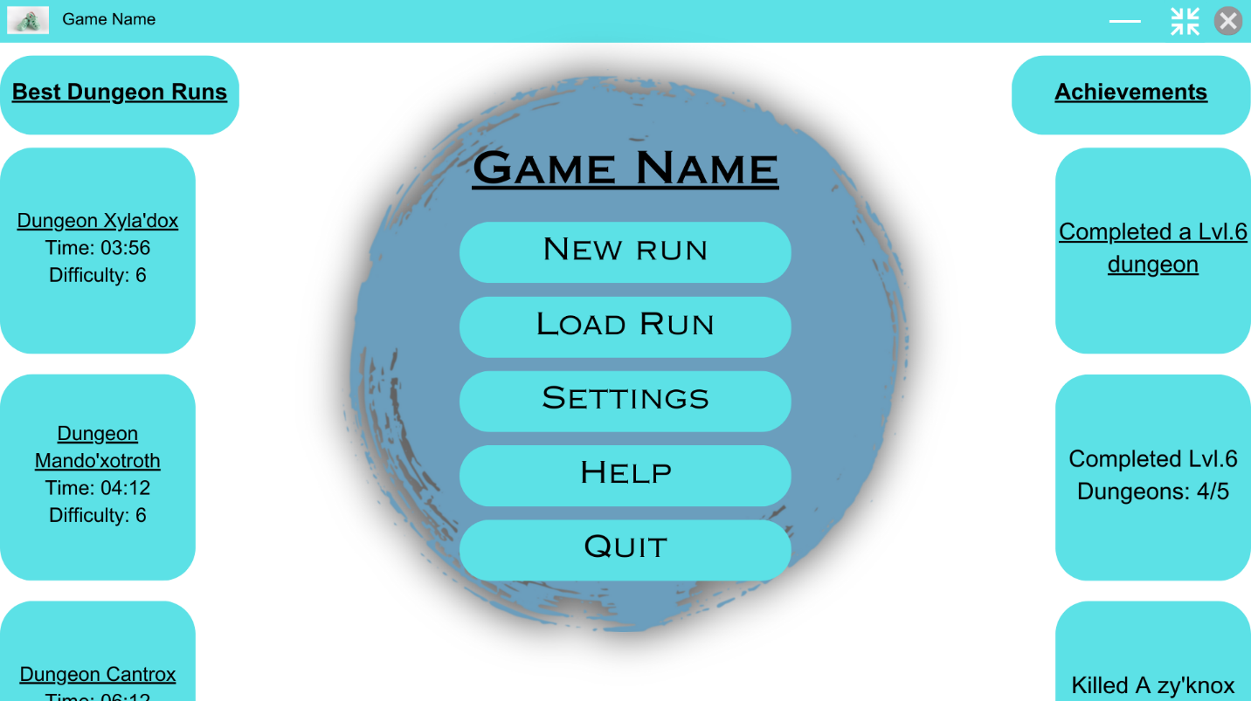

For the title screen of my game, I want to have two scrolling columns, one on each side of the screen, that show the players best dungeon runs and achievements throughout their different playthroughs.

I also want to have, in the middle of the screen, the games name which hasn’t been decided yet, which is followed by 5 buttons, which should be New Run, Load Run, Settings, Help and Quit. These buttons are rather self-explanatory, “New Run” will be used to make a new dungeon run save, I want to have 5 save slots, this forces users to either play all the way through or overwrite old saves. But I do want to have a sort of ‘archive’ features, where you can save a game save outside of the main menu, so it doesn’t take up one of your slots, and can later be imported back into a slot.

The ”Help” button is there for new players, I will make a sort of wiki on how to play the game, base controls, and functionality.

This menu is the “title screen” and will appear when you open the game, its use is to give the user options and info, but to also gradually lower them into the game, instead of throwing the user into gameplay as soon as they open the program.

This links to the solution requirements because it is user friendly, due to it being similar to other games but also the difference in features that the user can interact with and the non-functional elements.

**New Run Screen**

On this screen the player will be able to choose one of the five save slots to create a new game, and if there is already a game saved in the slot you choose you will get a prompt asking if you want to overwrite the save file.

This links to the solution requirements, because in order for my project to be considered a success I want the user to be able to save progress.

The load run button will be pretty much the same screen; however, the title will be “Load Run” and won’t open the game creation menu when you click on a save slot and will instead open it.

For my settings menu I want three sections, the section currently selected will be highlighted so that the user can easily tell which one they have currently selected. A lot of different types of software use this type of feature to help the user, and its use is easily picked up on, because of this, no explanation is needed for the user for them to understand how the menu system works.

The first one for controls will have three columns, one for the action names, one for the button that activates it and then a reset key for each to reset the actions button to default.

Each action should be categorized by their effect, for example the first 5 rows are separated from the others because they are movement related.

I also want to have the scroll bar on the side so the player can scroll down to see the rest of the settings.

When I am designing the assets, it may look different to the current setup as well as the other designs shown here, because I am not entirely sure on this design at the moment

In the second section, for graphics, I want there to be a list of options with various methods to change them, such as a slider, a drop-down list, checkboxes and maybe more. These options will be focused on the graphics of the game such as limiting fps so the player can limit the CPU usage of the program.

The different types of options are used in many other programs and are intuitive to use, such as the drop-down menu. The arrow on the drop-down boxes helps make the user aware that it is interactable and by hovering over it, a menu appears below the box showing different options. A drop-down menu is the best choice for settings such as “Resolution” because it is compact and allows the user to select one option out of a list that takes up the same amount of space no matter how many options are in the list.

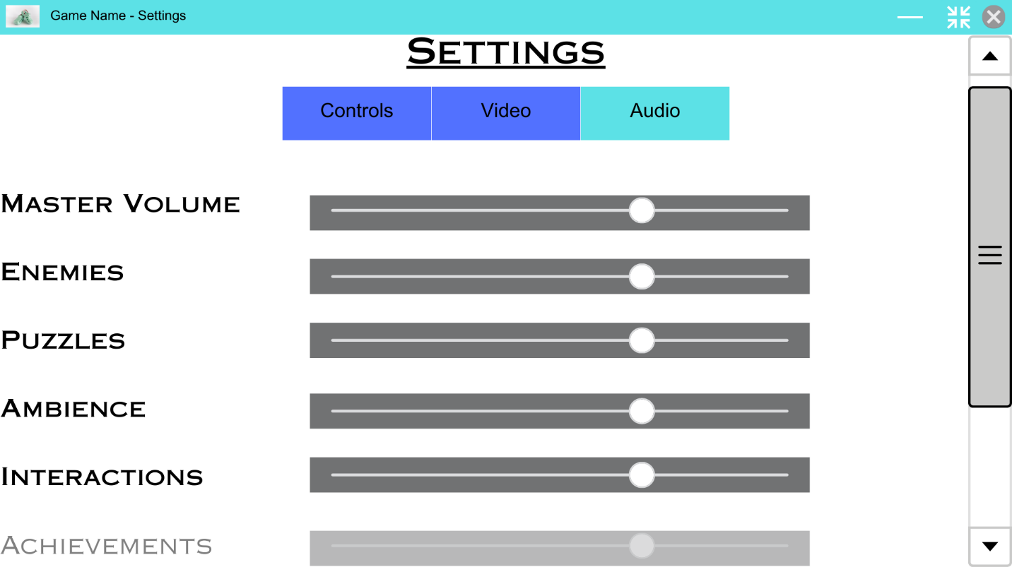

The Audio section will contain a list of the various types of sounds that can play in the game along with sliders to change the volume of that type, setting the slider to its lowest will mute that type of sound entirely. As the entries within the list are within a certain range of the bottom of the screen, they will gradually get more transparent. There is a scroll bar on the side so the user can access any of the other types of sounds.

Scrolls bar are found in a lot of programs and so are easily recognizable, and user friendly. This means that no previous knowledge of the game will be needed to navigate the menus.

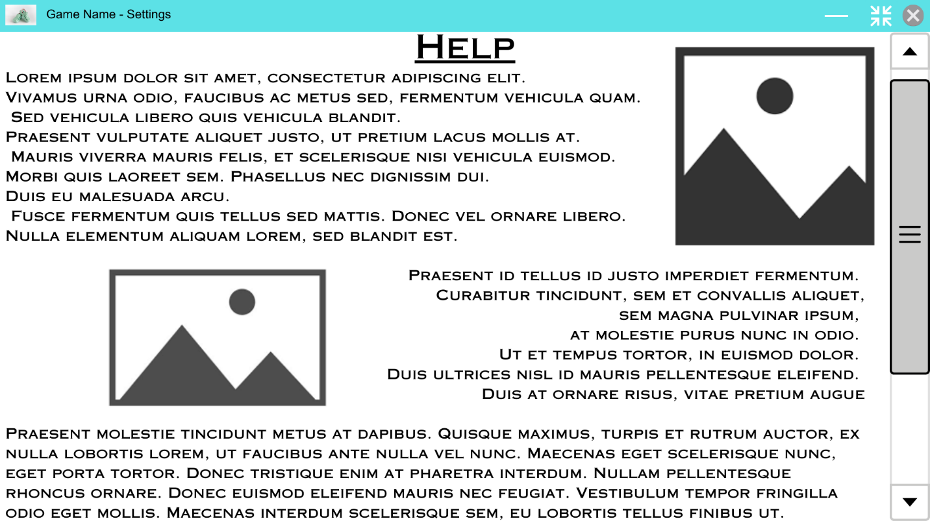

For the most part, the help menu will consist of text, with a variety of images scattered throughout to help guide the user. However, at the bottom of the page, I wish to include a link which opens a wiki that delves into more detail of the game and has a better guide on it.

I have used Lorem Ipsum as placeholder text for the help page since I have not fully settled on what kind of help will be on this page.

The help menu won’t have any interactive elements except for a back button and the wikis link, this is because it is meant to act as a small guide and not as something which affects the users playthrough of the game.

Throughout the help menu there will be many titles which show off the different parts of the small guide, the user will be able to select these different sections through a separate menu that could slide from the side of the screen into view.

This is an example of what that side menu could look like when extended.

It would include a list of all the titles on the help page, each of which acts as a link to that part of the document.

**In all of the settings sections, I have made the buttons have a large appearance and have a high contrast with the background so that the experience is easier for most users and consequently, there is less white space left over, which if there was more of could make the menu more boring.**

**Game Screen**

The game screen will be where the actual game content will be drawn, such as the player, the environment, enemies etc.

The other screens shown so far will be overlays that get drawn on top of the game screen if they are open.

When the program is run, a background image will be drawn onto the game screen since a game hasn’t been loaded yet, this could look like:

This system will be helpful since it will make other overlays later in the game such as a pause menu easier to implement. If I make the overlays work on an element-based system then I could develop different types of elements such as a button, that would allow me to not only design these overlays easier, it will make the system easier to develop in the future, by implementing different elements.

When the player has loaded a game whether it be a new save or an existing save, any open overlays will be closed and the program will start the game and draw the environment and everything else needed onto the game screen.

Any in-game overlays will then be drawn on top, this will include the HUD (Heads-up display), the HUD will show information such as health as well as what items the player has and any other information that is necessary.

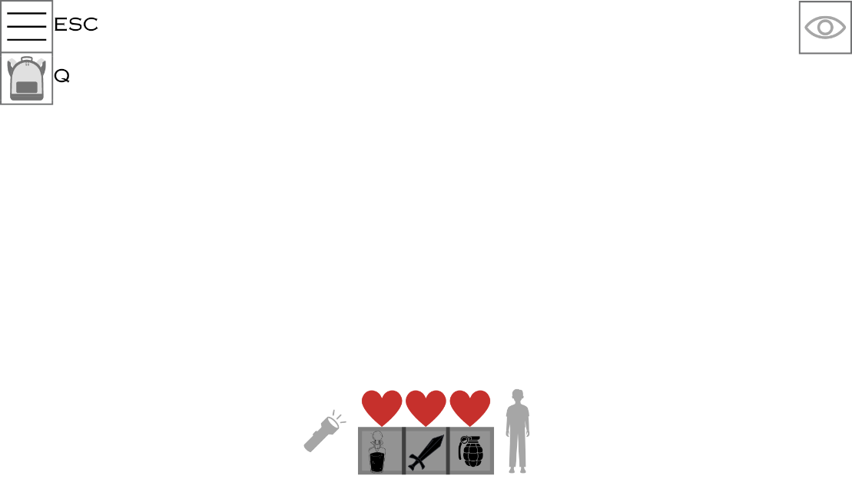

This is what the HUD overlay could look like when its implemented.

Overlays accessible by buttons.

At the top left of the overlay, there are some symbols. The three lines is in most games recognized as a pause menu, this will contain different options that the user can use to change their gameplay, such as changing the max fps, graphics etc. Pressing the shortcut related to the button will open the pause menu overlay and close the HUD overlay.

Underneath the pause menu symbol there is a backpack symbol, when the keyboard button is pressed, the game will open the users’ inventory and display it on screen in boxes like the hot bar (bottom middle). The inventory will have a max size of 9 slots which can be upgraded later in the game.

As shown on the HUD, whenever a button has a keyboard shortcut it will be displayed to the side of the box, (this can be turned off in the pause menu), this is for new players to help them learn the controls.

Hotbar

The hotbar can hold 3 items chosen by the player, this allows the user to easily switch what item they are currently holding by switching between the three slots using the 1,2 and 3 numbered buttons on the keyboard, as well as potentially using the mouse wheel.

The user can choose what items show up in the hotbar through the inventory, by dragging a slot of the inventory onto a slot of the hotbar, this will overwrite the item displayed in that slot of the hotbar. The item shown in the hotbar will not be taken away from its slot in the inventory, instead it will act as a sort of shortcut to the item in the inventory, so If the player uses up that item (item gets destroyed), it will be removed from the inventory and therefore be removed from the hotbar.

Torch

To the left of the hotbar is a torch icon, this is a simple graphic on the overlay that will show to the player if their torch is on.

I may also add a battery charge to the torch, shown by a percentage bar underneath the icon, to add an extra level of gameplay, where the player may have to wind up the torch to charge it, this will take time but will also produce noise that may make enemies investigate.

Crouching Mechanic

The crouching mechanic is one that I’m interested in at the moment.

If the player is standing normally then the icon to the right of the hotbar will show a character stood up, however if the player is crouched it will show a crouched character and the player will a debuff to their speed.

Crouching will mean that the player will be able to hide behind and inside certain objects to avoid detection.

(May not be implemented)

Health

Above the hotbar are 3 hearts.

These hearts can be full, half depleted and empty. If all hearts are empty, the player is dead.

Damage dealt by attacks from enemies will be rolled as a dice, and can be anywhere between 0 damage, 1 damage (half a heart) up to 1 and a half damage.

At the start of a dungeon run the player will have full health, they may obtain potions throughout the game that will heal them a bit, drinking a potion may increase your heart rate.

Eyeball

At the top right of the HUD, there is an eyeball, if the eye is open, it will mean that the player has been detected and is being ‘hunted’ by the enemy, if the player can avoid the enemy’s eyesight long enough, eventually they will give up and the player will be ‘hidden’ again.

## Systems diagram

# C. Developing the coded solution

## Developing the overlay manager.

During this stage of development, I have to make the overlay manager, as well as some other classes that will work within it.

Overlays will be the driving force behind the User Interface, for example, the game will have 1 overlay manager and will contain (Overlays), Overlays are groups of elements such as text boxes, buttons etc. The New Game screen will be an overlay which will contain 5 buttons which represent game slots.

Overlay Manager Class Structure:

Constructor:

VARIABLES:

Initialize the pygame surface as well as needed variables:

Overlays -> List, will contain a list of the overlays contained within the Overlay Manager, these are the overlays the manager will have control over.

Screen -> pygame.Surface, is the surface that will be drawn to the game window on top of all other surfaces, this contains the visual elements of the visible overlays within the Overlays list.

Name -> string, Contains the name of the Overlay Manager

Screen Flags -> List, Contains all of the flag integers for the screen, e.g. pygame.SRCALPHA – Allows for transparency

Size -> (int, int), Contains the width and height of the screen object

Held Down Keys -> List, Contains the keys on they keyboard that the user is currently holding down

Hitbox -> pygame.Rect(), Contains the x,y,width and height position of the screen in one place

!!!x,y -> (int,int), The position of the overlay manager – isn’t used, probably wont ever be used!!!

METHODS:

Update Hitbox -> Update the hitbox variable in case any changes are made to other variables that would affect the hitbox

Get Key State Event -> Gets the state of a key from the ”Held Down Keys” variable if the key is logged in the variable, else return false

Set Key State Event -> Sets the state of a key from the ”Held Down Keys” variable

Append Overlay -> Appends an overlay to the overlay list and sets the overlay parent equal to the Overlay Manager

Remove Overlay -> Removes an overlay from the overlay list and sets its parent to None

Insert Overlay -> Inserts the overlay into a specific index of the Overlays list

Move Overlay Forward -> Moves the overlay forward in the list by a specific amount so it gets rendered later on

Move Overlay Backwards -> Moves the overlay backwards in the list by a specific amount so it gets rendered sooner

Is Overlay At Pos -> Finds an overlay in the Manger at a set of coordinates, return True if one is found else return False

Get Overlay At Pos -> Finds an overlay in the Manger at a set of coordinates, return the overlay if one is found else return None

Get Overlays At Pos -> Finds overlays in the Manger at a set of coordinates, return the overlays found

Get Overlay By Name -> Finds an overlay in the Manger with a matching name, return the overlay found if one is found else None

Get Visible Overlays -> Finds overlays in the Manger that are set to visible, return the overlays found

Set Overlay Visible -> Sets an overlays state of visibility

Pre Update -> Called before all overlays update function is called

Post Update -> Called after all overlays update function is called

Pre Draw -> Called before all overlays surface are drawn to the Managers screen

Post Draw -> Called after all overlays surfaces are drawn to the Managers screen

Pre Overlay Update -> Called before each overlays update function

Post Overlay Update -> Called after each overlays update function

Pre Overlay Draw -> Called before each overlays surface are drawn to the Managers screen

Post Overlay Draw -> Called after each overlays surface are drawn to the Managers screen

## Evidence of overlay managers implementation

**Constructor Method Implementation**

**Properties**

**Getter and Setter for events states**

**Append, Remove and Insert function for the overlays**

**Move overlays in list**

**Overlay at pos?**

# D. Evaluation

<See H446-03 Project Advice Booklet for help and guidance of what must go here.>

# Project Appendixes

Insert as many project appendixes as you need for your project.

These might include, but are not limited to:

* Complete Code Listing (ESSENTIAL)
* Interview Transcripts
* Meeting notes
* Observation notes or questionnaires